JP Morgan Chase
Visa Card Reference Information

- Primary Contact: Laurie Hotchkiss, Procurement Card Administrator
  - Email: lhotchkiss@lynn.edu
  - Cell Phone: 561-479-7709 Alternate phone: 203-535-8098
  - Vacation Coverage: Jenny Lawrence

- I am available most of the time for help by calling the cell phone number. If by chance I am unable to answer the phone and you need immediate assistance, please call JPMorgan 800-316-6056

- You will need a 4-digit code to access your information, please reach out to me for your access code.

- Compliance Requirements:
  - Never send your complete card number on an e-mail or Fax.

- Please sign up for Fraud Alerts: To Activate a PIN number or sign up for Fraud Alerts
- Set up PIN -call 800-316-6056 and select #3. Good to have if traveling Internationally.
- Create fraud alert go to ccportal.jpmorgan.com
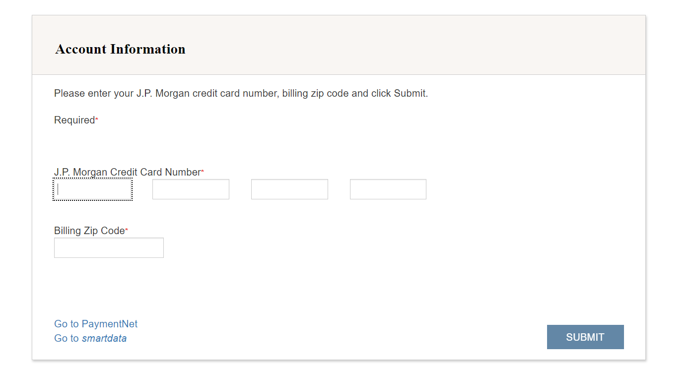
- Expiring cards:
  - JPMorgan issues new cards every three years (one month prior to expiration)
  - Cardholders will pick up the card from our office and we will activate new cards for you.

- Requisitions:
  - Before you begin to process your next requisition, ask the vendor if they accept VISA. Also check if there are fees if paying with a credit card, we do not recommend paying the fees.
  - Lynn University is tax exempt. TE number is printed on card, or provide the Florida Cert DR-14 form to the vendor

- Requisitions and Expense Reports:
  - Reconcile transactions in Work Day by the 5th day of posting. We recommend going into Work Day Daily or Weekly depending on how frequent you charge.
  - Submit itemized copy of meal receipts, listing the business purpose and names of attendees
  - Include copy of invoice as attachment along with payment receipt. Good practice to take a photo of the receipt to prevent missing receipts. You can upload the receipt into WD from your mobile device
  - Cardholders that hold two cards, please remember that the P-card (Purchasing) is to pay for invoices, store purchases, membership and anything other than Travel related expenses
  - Expense Card is to used for business expensed purchases related to Travel

- Spending Limits:
  - Check your single and monthly credit limits before paying for invoices or traveling with a group.
  - We can adjust your credit limits upon request as needed.

- Hotels:
- Hotel contract partners for Fiscal Year 2024 (FY24) – July 1, 2023 – June 30, 2024
- Hilton Garden Inn
- Hyatt Place Boca Raton
- Sonesta Select Boca Raton
- Wyndham Hotel Boca Raton
- Make your reservations @ https://www.lynn.edu/about/location/where-to-stay

- Rental Cars: Use our Contracted Rental Car Companies when booking a rental car:
- We have preferred pricing and our rates includes insurance coverage when traveling on business
- Avis –https://www.avis.com/en/corporate/A056011
- Budget – https://www.budget.com/en/corporate/T137200
- Enterprise/National – Lynn ID # FL41142 Please include this number for the coverage and discount.
- https://elink.enterprise.com/en/23/08/lynn-university.html

